|  |  |
| --- | --- |
| **STUDENT NAME** | **Abdullah Muhammad Ibrahim** |
| **STUDENT ID** | **SP20-BSCS-0027** |
| **SECTION** | **AM** |
| **ASSIGNMENT NO.** | **03** |

# **Output:**

Case1:

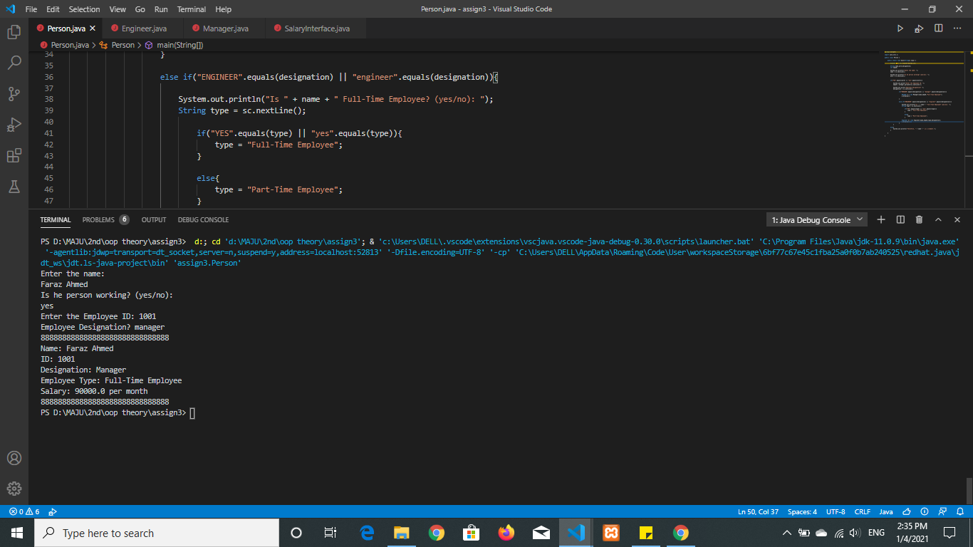

Case2:

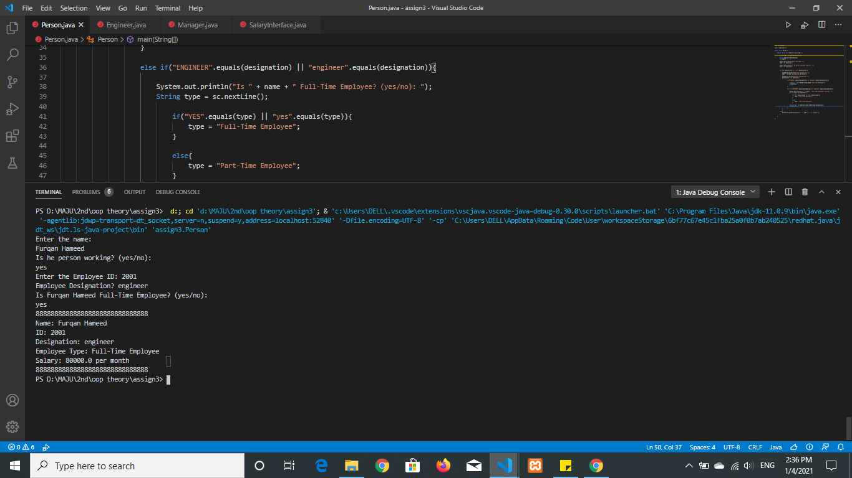

Case3:

